# Smart Signup

Smart Signup is a web application that allows a user to provide his details in order to sign up for a service. It is a 3-step wizard based web form. A user can proceed to the next step once he has correctly filled in details for any step. At every step, there are indicators if user enters incorrect data.

Step 1: User is asked to enter his details-name, role, email address and password

Step 2: User is asked what kind of product updates he would like to receive

Step 3: Confirmation message that the user has successfully signed up for the service

## Demo

The app has been published here for easy viewing

<https://master.d3k3jxmssqja9a.amplifyapp.com/>

## Installation Steps

1. Clone the project to local directory using

git clone <%repo url%>

1. Navigate into the directory where the project has been cloned. Open command line and install project dependencies using

npm install

1. Start the application using

npm start

1. The application should now be running at

http://localhost:3000/

## Code Overview

The application is based on a configurable form wizard. The pages that appear at each step are configurable.

* The application is based on React 17 + Javascript.
* React Hooks and React context has been leveraged for state management.
* Formik library has been used to build the forms
* Bootstrap is used as UI framework
* SASS has been used for CSS pre-compilation
* Test cases have been written using Jest + react-testing-library

## Directory Structure

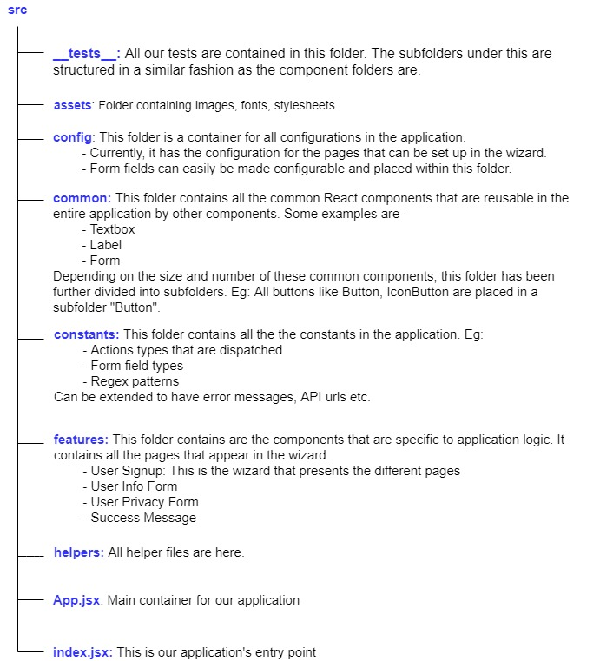

## Limitations and Improvement Areas

* More thorough and complete test cases
* Responsiveness of UI. Layout breaks when window size is small. This needs to be fixed
* Since the pages are configurable, handing use case with invalid configuration needs to be added